**StyleShow Application Proposal:**

My proposed app is StyleShow, a social media application centred around shoes. StyleShow can be used to find popular shoes and to identify fashion trends. It also creates a platform for shoe enthusiast to communicate and share their passion for shoes.

Users will be able to create a shareable post with an image and caption. Other uses can ‘like’ and add comments on such posts. Users will be able to see a randomized feed, a most popular feed, and a personalised feed which only consists of posts made by users they follow. Users will also be to privately message other users.

The app’s UI will follow the [Material Design 3](https://m3.material.io/) guidelines. The app will use a custom server API written in JavaScript.

Features:

* Screen to be able to create account, or sign in.
* Ability to CR_D a post.
  + Permission to access camera/camera roll.
  + Ability to CR_D a post comment.
* Ability to privately message other users (CR_D).
* Push notifications whenever user receives a message, implemented using a custom Service.
* Ability to switch between random, most popular, and personalised feeds.
* Ability to follow other users so their content shows up in personalised feed.
* Ability to search for a specific user.
* Ability to CRUD the user’s profile:
  + Change username, profile picture, bio, password.
* Ability to switch between light and dark mode (stored in SharedPreferences).

**UI Sketches**

Register Screen:

* User enters credentials for a new account.
* Credentials are validated server-side and if successful, takes user to the Home Screen.
* If the user already has an account, they can reach the Sign In Screen from here.

Sign In Screen:

* User enters their credentials, which are validates server-side.
* If sign in is successful, take user to the Home Screen.

Home Screen:

* Displays the posts (will also display caption) that correspond to the currently selected feed type.
* Can access the Messages and New Post Screens.
* Features the common bottom nav.

Post Screen:

* Will also display post caption.
* User can view post comments.
* User can comment on the post.
* Tapping on the author’s username takes the user to their profile page.
* Post author will have a button that will take them to the New/Edit Post Screen.

New/Edit Post Screen:

* The user can manage a post’s contents - image & caption.

Messages Screen:

* Displays all the user’s conversations, with the most recent message as a preview.
* Sorted by conversation with the latest activity first.

Chat Screen:

* The user can send a private message to another user.
* The user can view the private messages received from this user.

Search Screen:

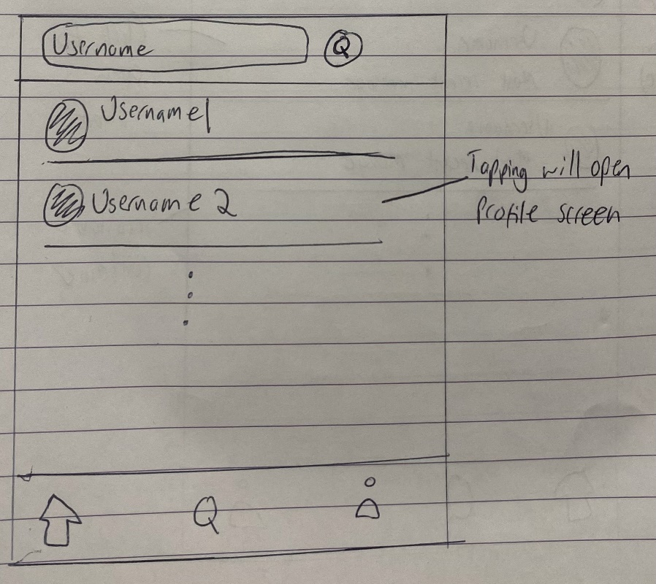

* User can search for a user by their unique username.

Profile Screen (not the signed in user):

* Signed in user can follow/unfollow this user.
* Displays the posts this user has made.
* Signed in user can send a message to this user.

My Profile Screen:

* User can view the posts they have posted.
* User can go to Settings screen.

Settings Screen:

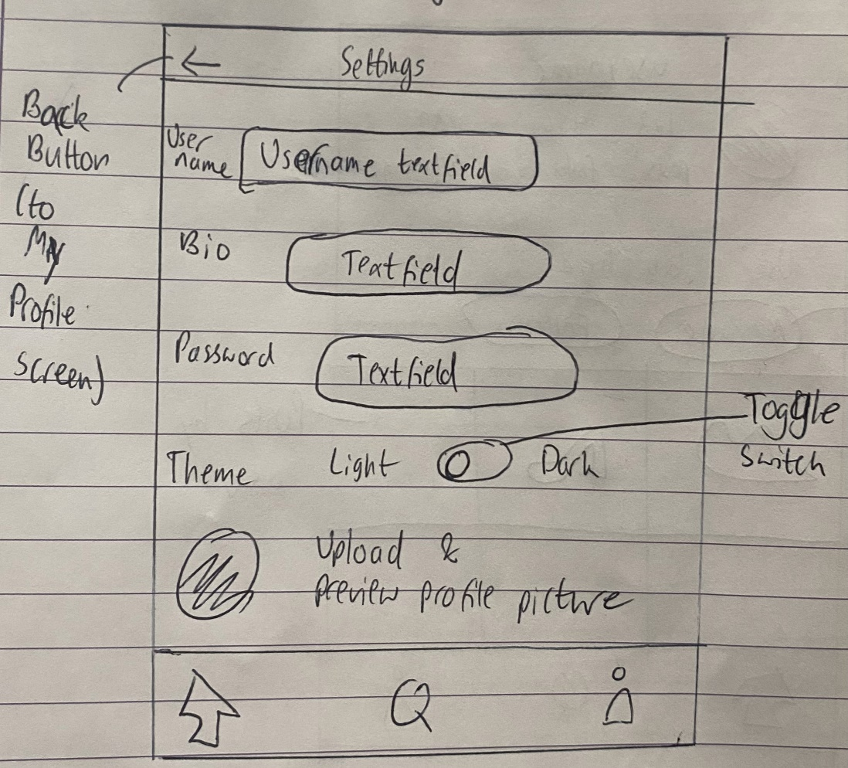

* User can change their username, profile picture, bio, and password.
* User can toggle between light and dark mode.